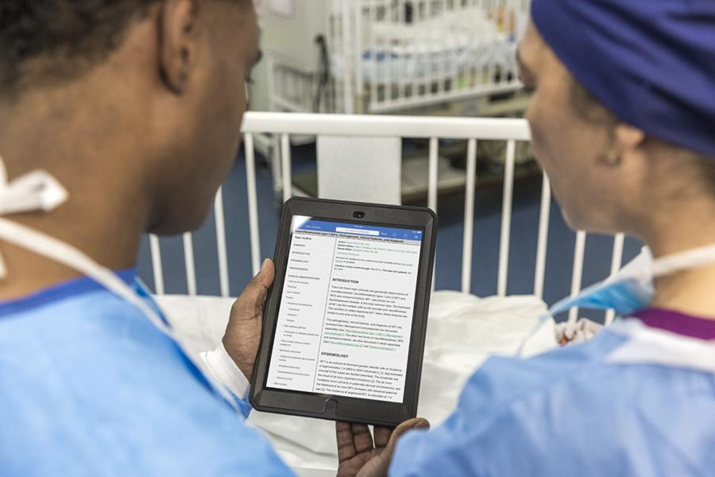
Through the Better Evidence Program, all medical trainees and faculty at [name of school] can now access UpToDateⓇ, a clinical decision support tool authored by 6,900 world-renowned physicians who synthesize the most recent medical information into trusted, evidence-based recommendations accessible via the web or download, on a computer or a smartphone.

To register for your account:

- Visit www.uptodate.com/online
- Click “Register” in the top right corner
- Complete the registration form to create a login/password
- Click “Submit registration”
- Log in to use UpToDate

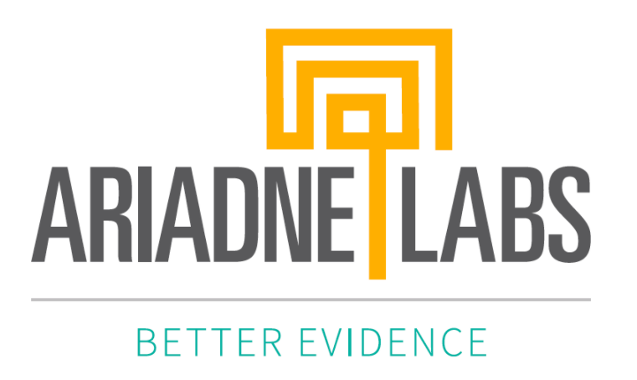 |  | School’s Logo

Through the Better Evidence Program, all medical students and faculty can now access UpToDateⓇ, a clinical decision support tool authored by 6,900 world-renowned physicians who synthesize the most recent medical information into trusted, evidence-based recommendations accessible via the web or download, on a computer or a smartphone.

To register for your account:

- Visit www.uptodate.com/online
- Click “Register” in the top right corner
- Complete the registration form to create a login/password
- Click “Submit registration”
- Log in to use UpToDate

School’s Logo

