Better Evidence Program
Through Better Evidence, UpToDate is now available for medical trainees and faculty of [name of school of medicine].
UpToDate is a clinical decision support tool authored by 6,900 world-renowned physicians who synthesize the most recent medical information into trusted, evidence-based recommendations accessible via the web or download, on a computer or a smartphone. Over 1.7 million clinicians in over 190 countries and nearly 90% of major academic medical centers in the U.S. rely on UpToDate to find the answers to pressing questions. Every day, clinicians worldwide view topics covering 25 specialties over 1.5 million times.
Registering for an UpToDate® Account through your university:
Visit www.uptodate.com/online, then click on the Register link in the top right of the page and complete the registration page.

Using UpToDate®:
Registering for an UpToDate account through your university provides access to UpToDate® Anywhere, a comprehensive, mobile-enabled resource that gives you access to UpToDate’s evidence-based clinical content when and where you need it. With UpToDate® Anywhere, you can:

Access UpToDate via a computer
- Access to UpToDate from any computer with an Internet connection (i.e,. your own personal laptop or a desktop computer in the University or library)

Access UpToDate via a mobile device or tablet
- Download the free UpToDate Mobile App for your iOS® or Android™ device (on 2 devices)
- Access UpToDate remotely from outside the [name of university]
- Use UpToDate offline, without a connection to the internet, through Mobile Complete

Maintaining Access:
To maintain uninterrupted access to UpToDate, you must confirm your affiliation with [name of university] at least once every 90 days by logging in to UpToDate from within the University’s network.

Need Help?
Write to the Better Evidence Program at betraining@ariadnelabs.org with any questions related to access or usability of UpToDate at your University. For technical questions, please contact UpToDate Customer Service at customerservice@uptodate.com.
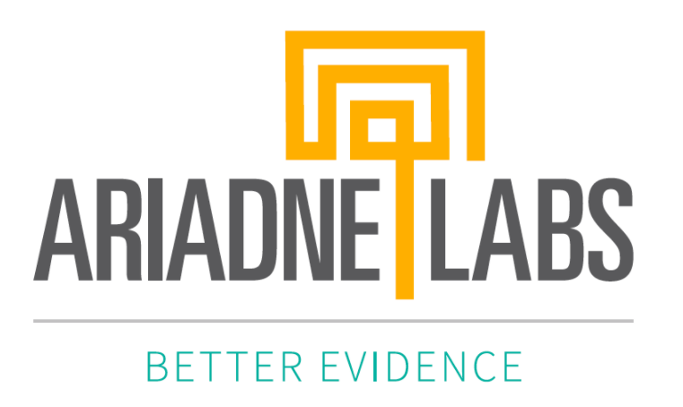 |  | School’s Logo

